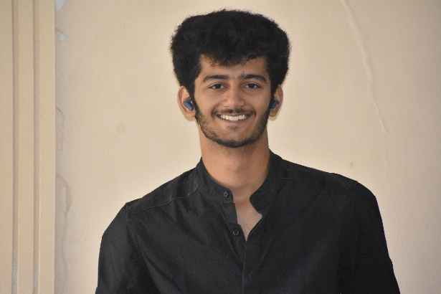 |  | ansh thakare
Objective  Enthusiastic and hardworking individual with a strong passion for presentations, public speaking, and idea generation. Skilled at clearly communicating complex concepts and collaborating with teams to brainstorm creative solutions. Looking for opportunities to contribute in dynamic environments where presentation and ideation skills are valued.  Contact  LINKEDIN-  www.linkedin.com/in/ansh-thakare-053783359  MAIL- thakareansh3@gmail.com  GITHUB- https://github.com/anshthakare16  MOBILE- 9226139414 |  | EDUCATION  Int BTech- SY Artificial-intelligence  And Data Science.  MIT World peace university  Kothrud Pune.  EXPERIENCE  Made successful presentations on the ideas taken into Hackathon,workathon,ideathons.  Student Attendance Tracker – Python + Streamlit  Built a web app for recording class attendance using JSON. Published at: https://attendancestraker.onrender.com  Neuroguard startup planned by Me– HTML with js backend  Published at: https://neuroguard.netlify.app/  Capstone final year team Registration – HTML, CSS, NODE.JS, JAVASCRIPT.  Published: https://mitcapstoneregistration.netlify.app/  English to sql Translator -python + streamlit  Built a website for teachers who don’t know anything about SQL commands, this website translates simple English language to workable SQL commands.  Published: https://english-to-sql-pbl2.onrender.com  Participated in the Smart Indian Hackathon, clearing all the internals and selected for the Government round.  PS- Neuromesh an platform for the FANET based drone connection. Published: https://neuromesh.onrender.com/  SIH 2025 problem statement 2- Block Chain Based Blue Carbon Registry  Ps- A block chain-based system for tracking and verifying blue carbon credits, ensuring transparency in carbon offset projects.  Published: https://sih2k25.netlify.app/  Movie Picker  Description- Movie Picker makes movie nights easy—just spin, and instantly get a random film suggestion from a curated list. No more endless searching or indecision—let the app pick your movie for you!  published: https://pop-spin-cinema.netlify.app/  SKILLS  - Creative Thinking & Idea Generation  - Team Collaboration  - Problem Solving  -Digital marketing (basic)  - Basic Research Skills  -strategy management  -social impact  STRONG area  Public Speaking & Presentations – confident and skilled in communicating ideas.  Idea Generation & Creative Thinking – enjoy brainstorming and improving plans.  Team Contribution –someone who actively participates and supports group work.  Problem Solving – think of suggestions to make things better.  Attention to Detail – Presenters often care about structure, clarity, and design.  Initiative-Taking – work hard when there’s something to build or pitch.  Adaptability – Good presenters often adjust quickly based on the audience.  Communication Skills

